1.A Linux OS on AWS means running a Linux operating system (like Ubuntu, Amazon Linux, Red Hat, Debian, etc.) on AWS cloud infrastructure, usually using an EC2 instance.
You create a virtual server in AWS, choose a Linux OS image, and AWS runs it for you in the cloud.

Main Things Needed to Create a Linux VM on AWS
These are the most important components/resources required.

1. AWS Account
First you need an AWS account.
AWS Console:
AWS Console

2. EC2 Service
AWS service used to create virtual machines.
EC2 Home:
Amazon EC2

3. AMI (Amazon Machine Image) — MOST IMPORTANT
This is the Linux operating system image.
Examples:
- Amazon Linux 2023
- Ubuntu
- Debian
- RHEL
- SUSE
The AMI contains:
- Linux OS
- Kernel
- Basic software packages
Example:
Ubuntu Server 24.04 LTS
Amazon Linux 2023
Without AMI → no OS.

4. Instance Type
Defines hardware resources.
Includes:
- CPU
- RAM
- Network performance
Examples:
t2.micro
t3.micro
t3.medium
m7i.large
For beginners:
- t2.micro or t3.micro

5. Key Pair
Used to securely log in via SSH.
AWS creates:
mykey.pem
You use it:
ssh -i mykey.pem ec2-user@public-ip
Without key pair:
- Cannot easily access Linux server.

6. Security Group (Firewall)
Controls network access.
Common rules:
Port | Purpose
22 | SSH
80 | HTTP
443 | HTTPS
Example:
Allow SSH from your IP
Very important for security.

7. Storage (EBS Volume)
Hard disk for the Linux VM.
Usually:
- 8 GB
- 20 GB
- 50 GB SSD
Types:
- gp3 SSD (most common)
Stores:
- OS
- Files
- Applications
- Logs

8. VPC (Networking)
Virtual network where VM runs.
Includes:
- Subnets
- Route tables
- Internet gateway
Default VPC is usually enough for beginners.

9. Public IP / Elastic IP
Needed if you want internet access to the VM.
Public IP lets you:
- SSH into server
- Host websites
- Access APIs
2. HOW TO CREATE LINUX VM
GO TO AWS ACCOUNT AND SEARCH EC2-
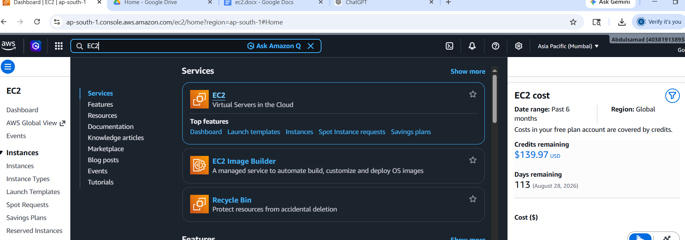

SELECT THE EC2 AND CLICK ON CREATE INSTANCE-
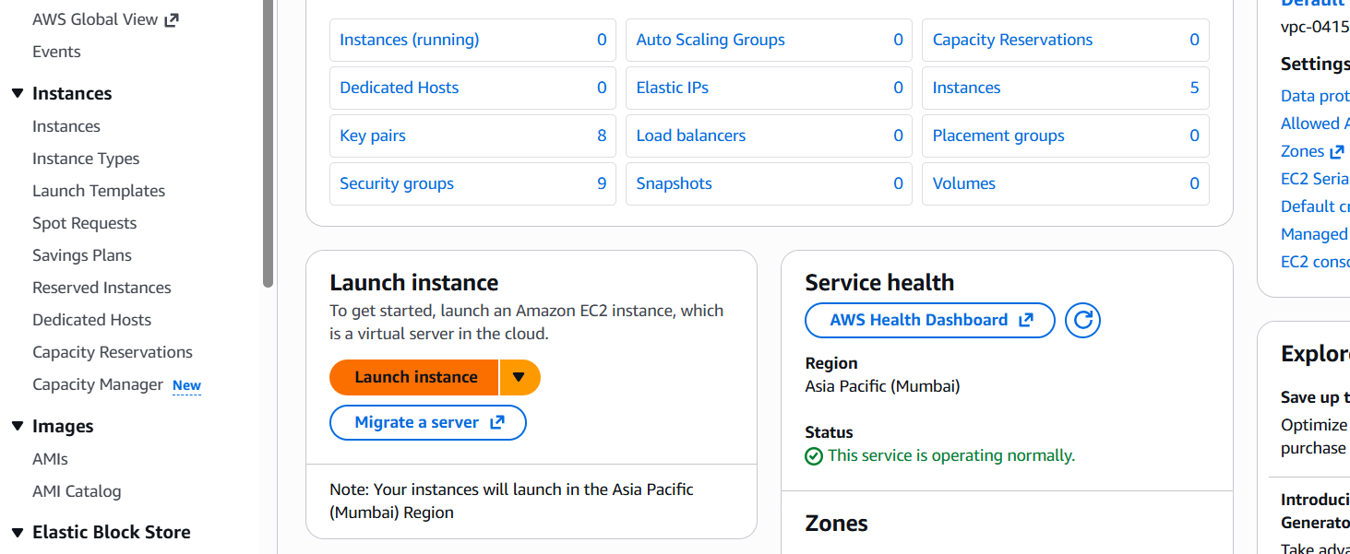

GIVE NAME TO VM AND CHOOSE OS LINUX
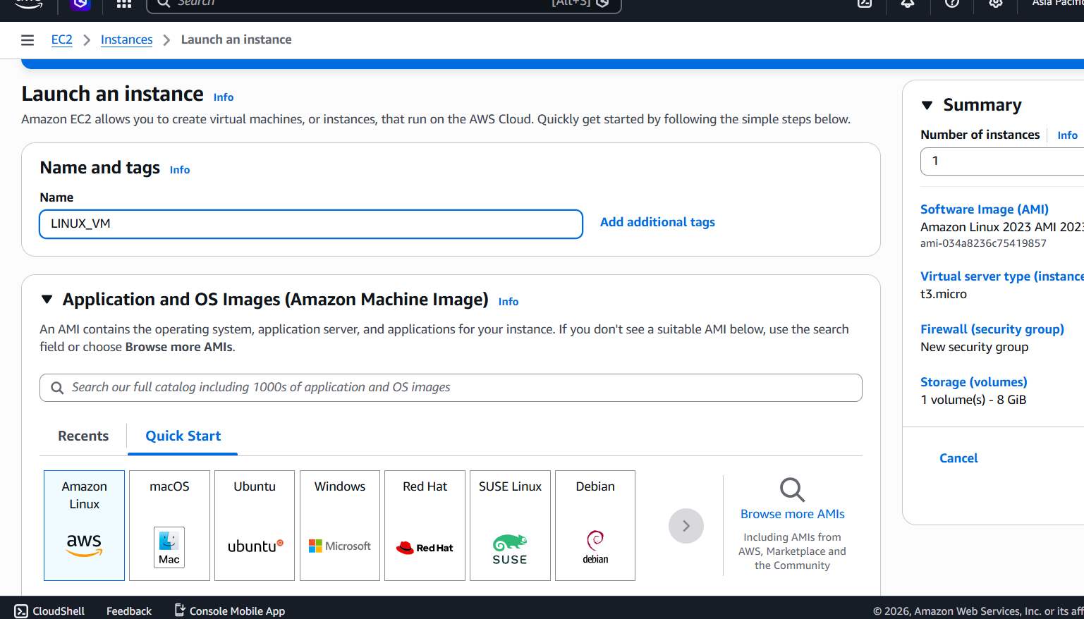
CHOOSE THE INSTANCE TYPE LIKE RAM AND CPU CORE AND CREATE KEY TO ACCESS THE VM
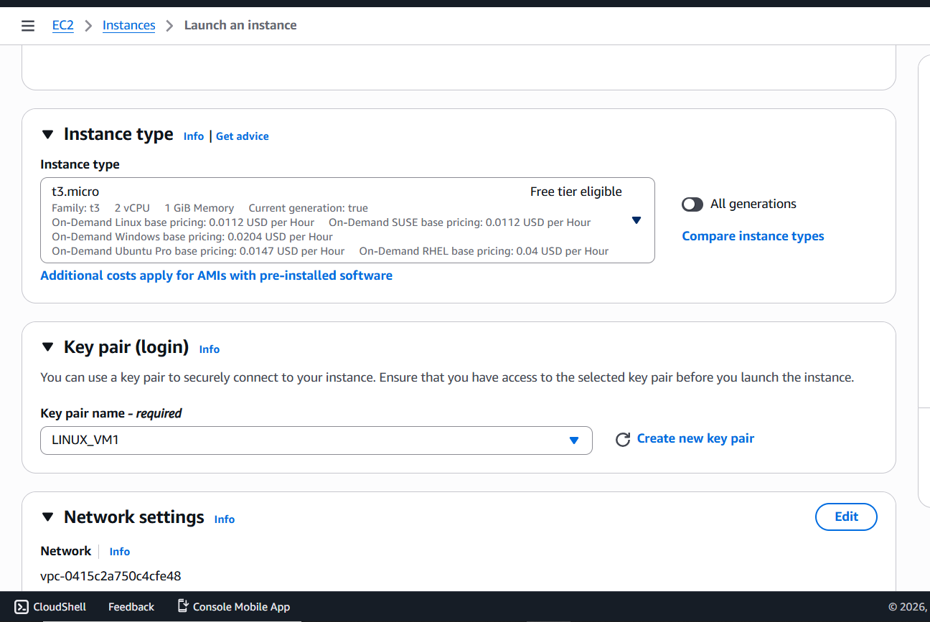

IN NETWORKING – NETWORK SECURITY GROUP- ADD SSH TO ACCESS VM REMOTLY.
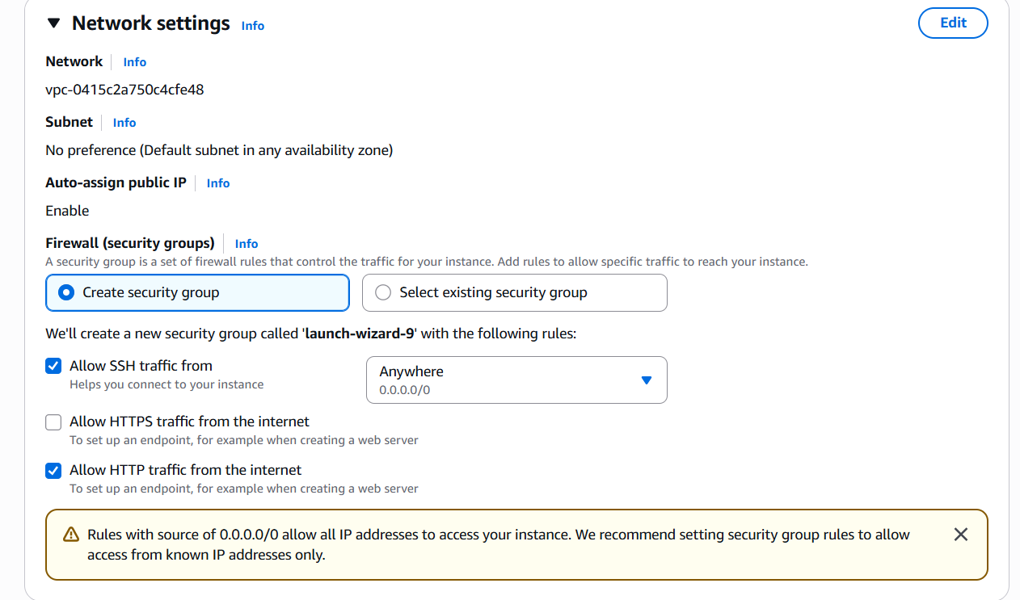
YOU CAN ADD STORAGE BUT BY DEFAULT THE LINUX SIZE IS 8 GB
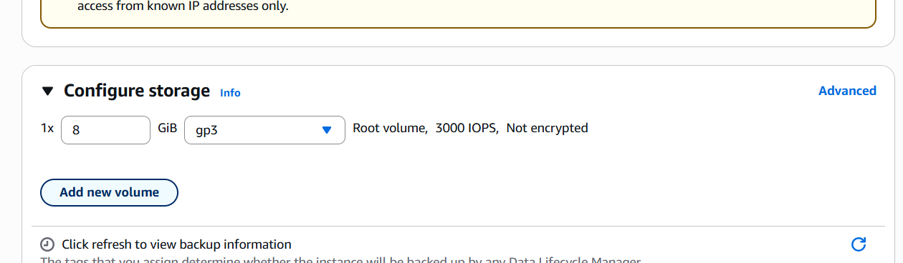
AND LAUNCH THE VM.
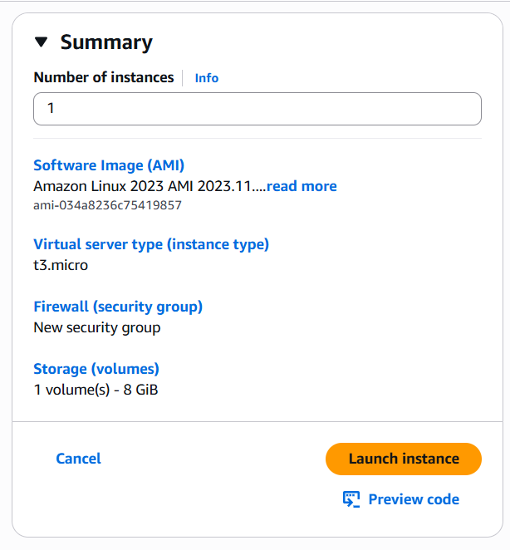

3) HOW TO ACCESS THE LINUX VM:-

CLICK ON INSTANCE THAT YOU WANT TO ACCESS AND CLICK CONNECT

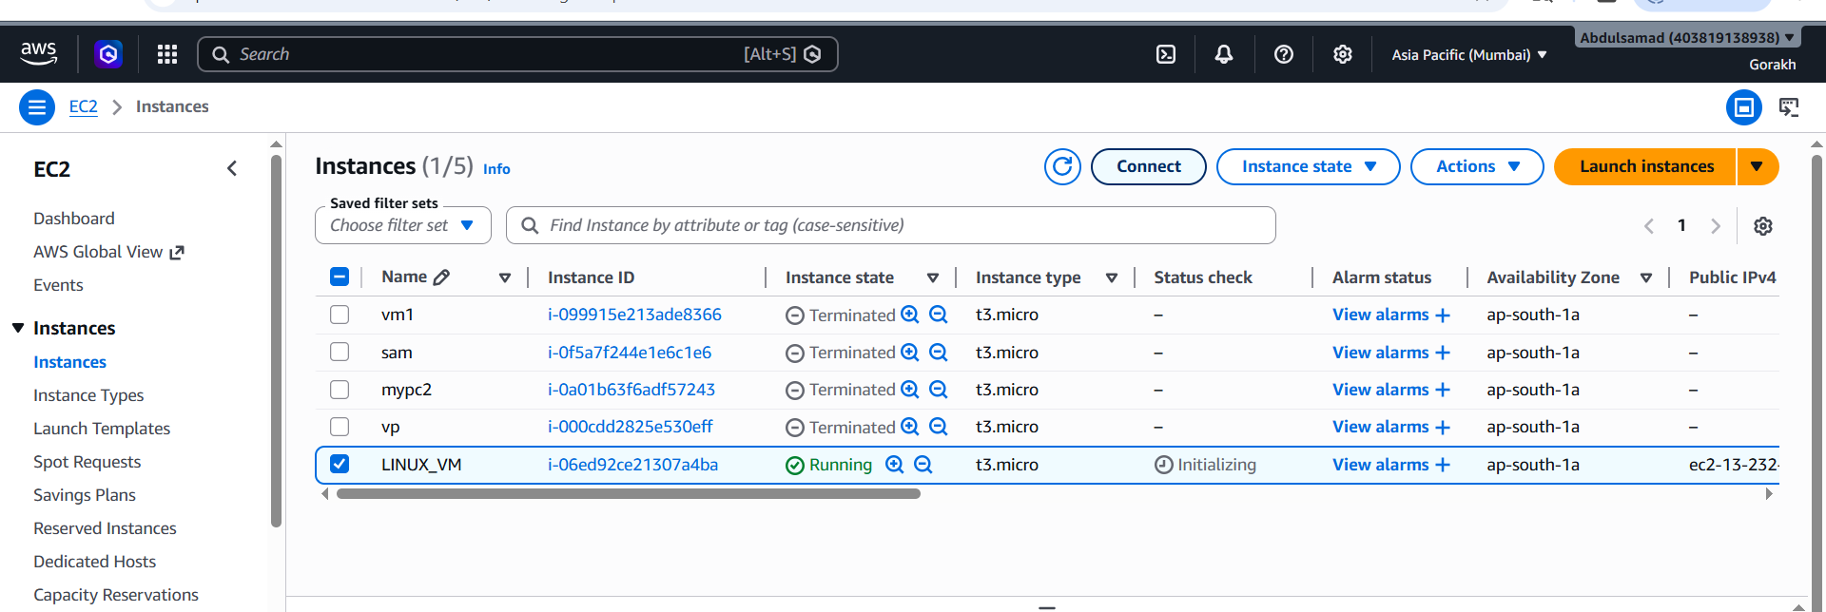

CLICK ON SSH CLIENT AND USE COMMAND TO ACCESS THE VM
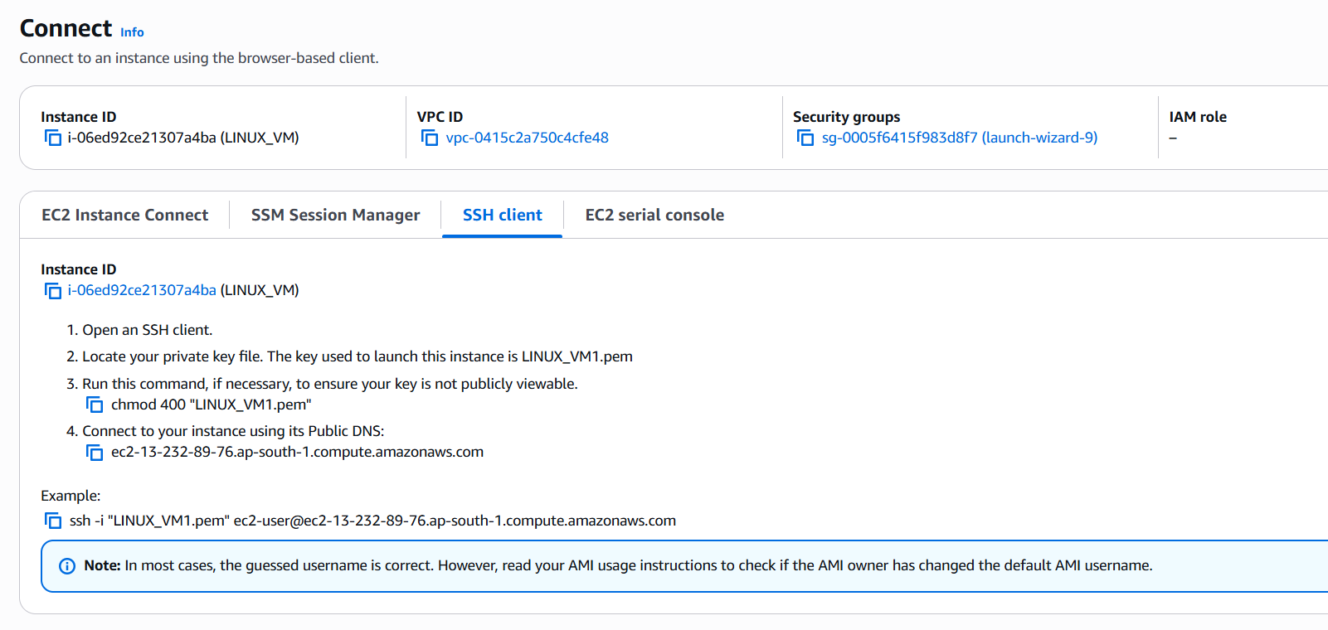

OPEN CMD AND USE BELOW COMMAND TO ACCESS THE VM.
-cd C:\Users\admin\Downloads
-dir
-ssh -i "LINUX_VM1.pem" ec2-user@IP_OF_VM
